**Analysis Conclusions**

The final KNIME workflow is shown below:

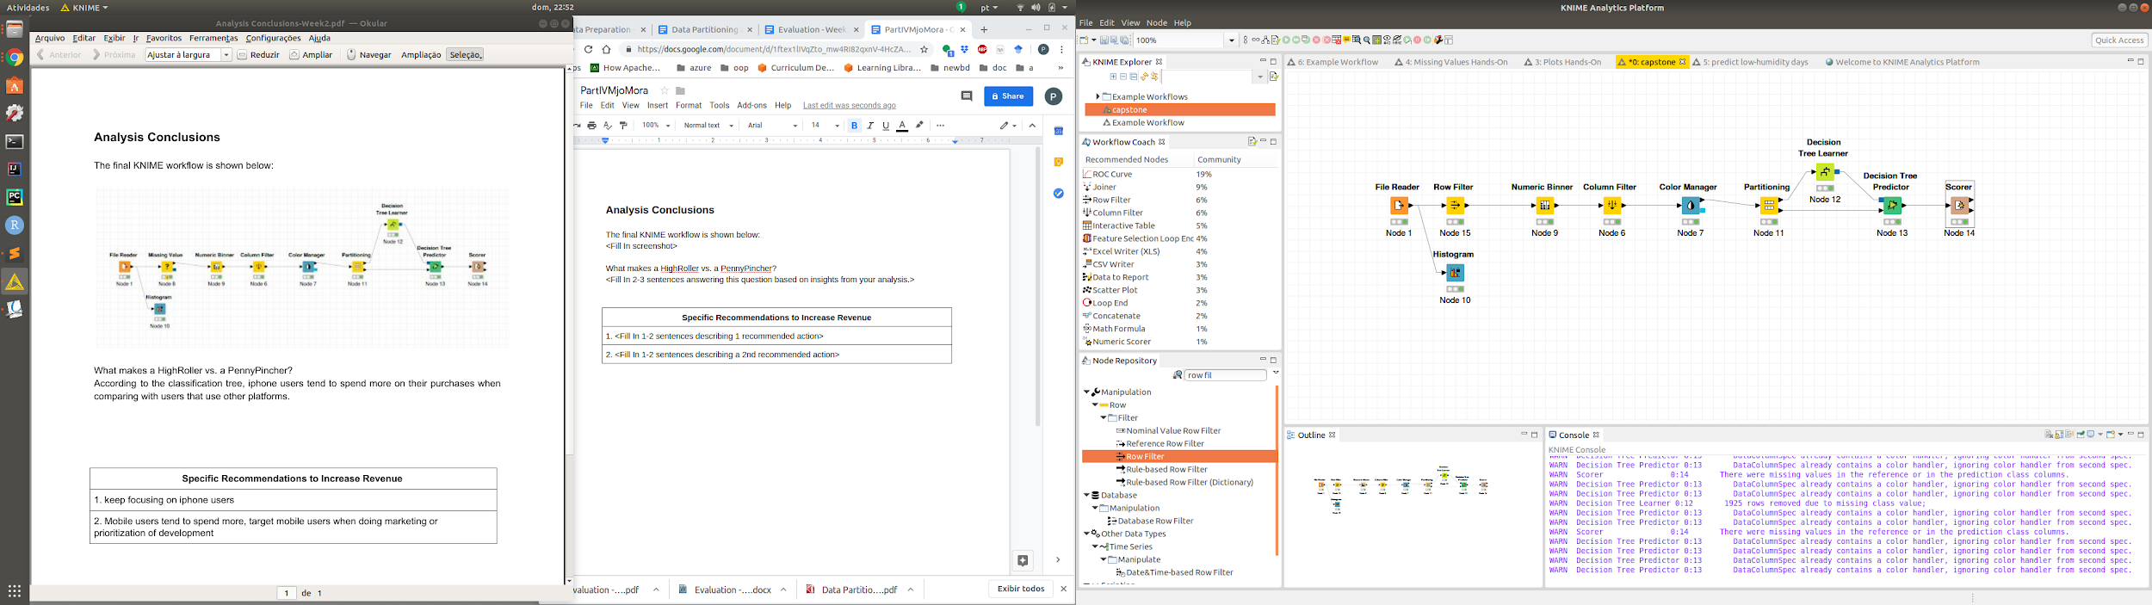

What makes a HighRoller vs. a PennyPincher?

According to the classification tree, iphone users tend to spend more on their purchases when

comparing with users that use other platforms.

|  |
| --- |
| **Specific Recommendations to Increase Revenue** |
| 1. Focus development and marketing initiatives on iphone users |
| 2. Give preference in terms of new developments or marketing to mobile users. |